

ANALYSIS OF MACHINE LEARNING JOB MARKET IN INDIA

# FeyNN Labs

## 25th May,2022

 **Bage Aman Shaikh**

# **Machine Learning Intern**



# **Abstract**

Segmentation is the process of isolating possible target groups in order to decide which ones would provide the greatest return on your marketing efforts. Segmentation is based on certain characteristics such as an individual's age, income, interests, and so on behaviors. When you segment different markets, you learn more about their core issues. Values, and what will finally entice them to buy your product. The distinction between traditional market segmentation techniques and job-based segmentation. For grouping consumers, the approach is the basic unit of analysis. For traditional the qualities of customers are the basic unit of study in segmentation. themselves. A job is the primary unit of analysis for work-based segmentation. Customers are attempting to complete tasks. The basic unit of analysis for traditional segmentation is the attributes of the clients themselves. A job that clients are attempting to complete is the primary unit of analysis for jobs-based segmentation. A market is traditionally characterized by the product and service categories defined by solution providers. According to Jobs Theory, a market is an aggregate of all available options, both provider and non-provider, that customers consider as being capable of meeting their demands in terms of getting a job done. Job segmentation provides a company with a substantial competitive edge because it allows them to predict the value that customers want—even before customers are aware of certain needs.

# **Introduction**

Machine Learning employment have increased tremendously in recent years, with a high market demand. As machine learning makes significant inroads into numerous businesses, so does the demand for machine learning engineers.

Machine learning (ML) is a subset of Artificial Intelligence (AI). AI is present everywhere, from gaming stations to the management of complex data at work. Engineers and scientists are working hard to install intelligent behavior in machines, allowing them to think and respond in real-time situations. AI is progressing from being a research issue to being in the early phases of enterprise implementation. Google and Facebook have made significant investments in Artificial Intelligence and Machine Learning and are already incorporating it into their products. But this is only the beginning; over the next few years, we may see AI creep into one product after another.

Simply expressed, the goal of AI is to make computers/computer programmes intelligent enough to mimic human mental activity. ML is the study of creating and implementing algorithms that can learn from previous situations. If a certain behavior has occurred in the past, you can forecast whether or not it will occur again. That is, if there are no previous cases, there can be no forecast.

ML may be used to address difficult problems such as credit card fraud detection, self-driving automobiles, and facial detection and recognition. ML employs complicated algorithms that run over enormous data sets indefinitely, evaluating patterns in data and allowing machines to respond to situations for which they were not expressly built. Machines learn from past to deliver

consistent results. To forecast reasonable outcomes, ML algorithms employ Computer Science and Statistics.

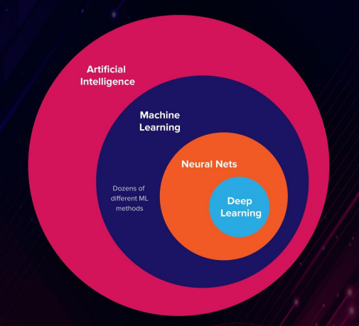

# **JOB MARKET OVERVIEW**

When it comes to work prospects, the scope of Machine Learning in India and other areas of the world is high in comparison to other career disciplines. According to a Monster research, big data analytics and AI/ML would be the most in-demand skills in India in 2022. According to a Monster analysis, with increased tech adoption across industries and totally tech-enabled areas like IT and BFSI, the role of AI/ML will only grow in 2022. The average yearly income of an entry-level AI engineer in India is around 8 lakhs, which is much higher than the average salary of any other engineering graduate. AI engineer salaries might reach 50 lakhs in high-level professions.

A fresher can get a machine learning job if he or she possesses the necessary abilities. To have a successful career in the machine learning landscape, newcomers must prepare how they will perform effectively and collaborate closely with others who have extensive experience in the same sector.

To Start Career in ML/ AI Field, following skills are needed (may be acquired):

* Statistical Skill
* Mathematical skills and Probability
* Programming skills
* Advanced Signal Processing Techniques
* Distributed Computing
* Work on projects

# **Problem Statement**

Finding Companies most probable to hire an ML Engineer/Data Analyst Applicant in respect to his/her skillset.

Data Collection/Scraping based on

1. Geography

2. Company’s field of work

3. Company size

4. Upcoming vacancies in respect to company’s growth (IPO/Funding etc.)

5. Machine Learning/Data Analysis Skills currently most demanded in the market in respect to

1. Experience required,
2. Time required to acquire the skill,
3. Vacancies open
4. Salary etc.

We have to analyze Machine Learning Job Market in India with respect to the given problem statement using Segmentation analysis and outline the segments most optimal to apply or prepare for Machine Learning Jobs.

# **Data Collection**

Data collection is defined as the procedure of collecting, measuring and analyzing accurate insights for research using standard validated techniques. A researcher can evaluate them hypothesis on the basis of collected data. In most cases, data collection is the primary and most important step for research, irrespective of the field of research. The approach of data collection is different for different fields of study, depending on the required information. To begin with, collecting data we should signify that empirical data forms the basis of both commonsense and data-driven job segmentation as it provides a clear base to work on. This data enables us to create job segments as well as give a grand picture and explanation of these segments. Although data is a valuable asset for every organization, it does not serve any purpose until analyzed or processed to get the desired results.

* Data Collection is one of the very crucial and difficult steps of data analysis.
* This part can be performed in various ways. For instance, from Kaggle, website or industry.

# **Exploring Data:**

Data exploration is the initial phase in data analysis and is used to examine and display data in order to uncover insights from the beginning or to identify regions or patterns to investigate further. Users may better understand the big picture and get to insights faster by using interactive dashboards and point-and-click data exploration.

This procedure facilitates deeper analysis by assisting in the targeting of future searches and initiating the process of removing irrelevant data points and search paths that may provide no results. More significantly, it fosters familiarity with existing material, making it much easier to locate superior answers.

Visualization is frequently used in data exploration because it provides a more straightforward picture of data sets than merely studying thousands of individual numbers or names.

The manual and automated elements of any data exploration look at different sides of the same coin. Manual analysis assists people in becoming acquainted with information and might reveal broad trends.

## **Exploring Machine Learning Jobs Dataset**

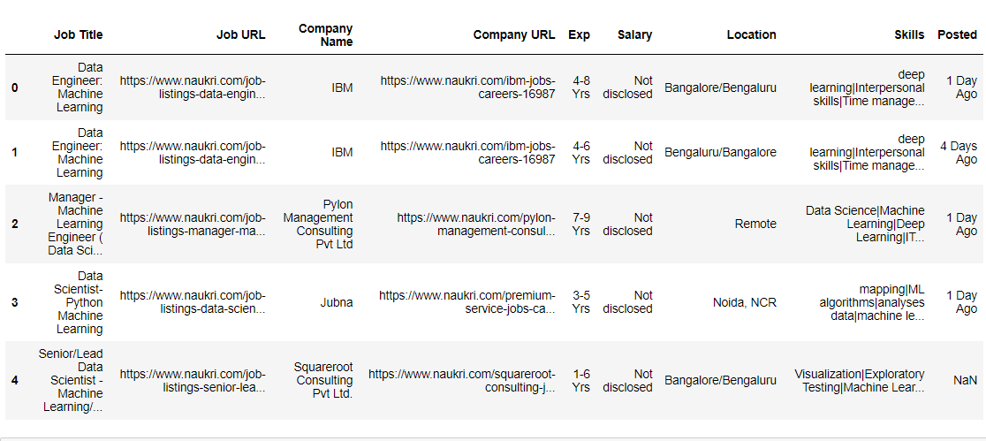

## **Checking for null values in the dataset**

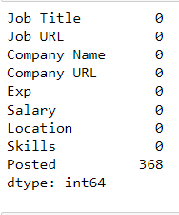

## **Columns of the dataset**

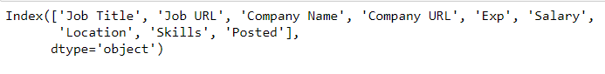

## **Location Wise Machine Learning Jobs**

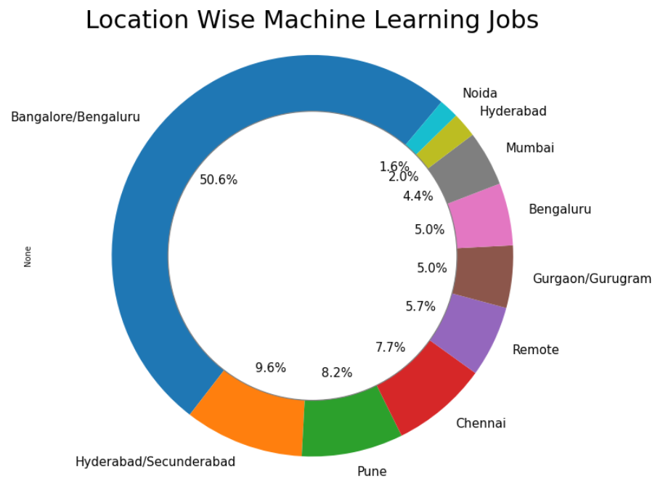

## **Companies wise job posting:**

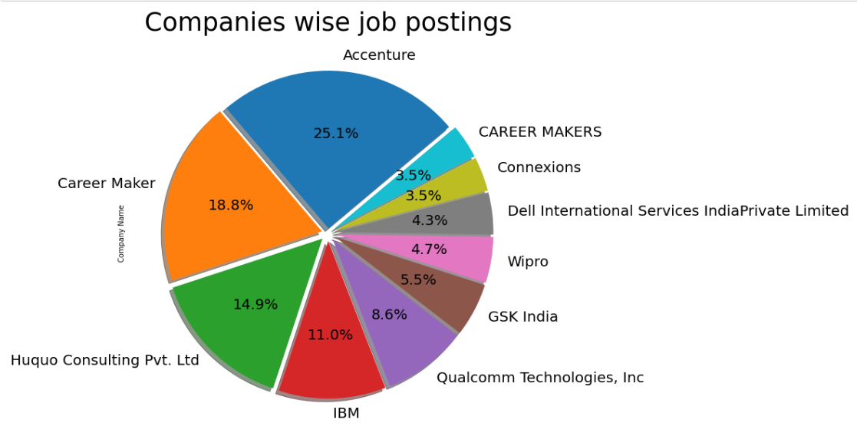

## **Experience wise No. of Vacancies**

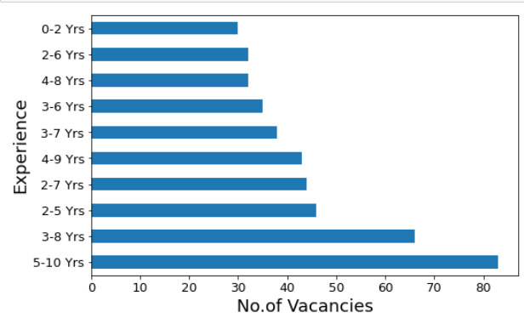

## **Machine Learning Roles in the Market**

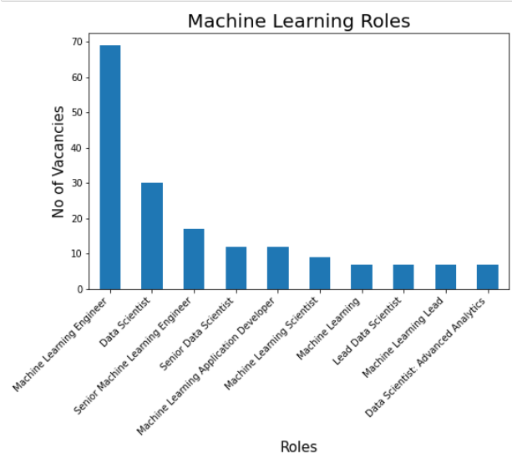

## **Skills wise plot of Machine Learning jobs in the Market**

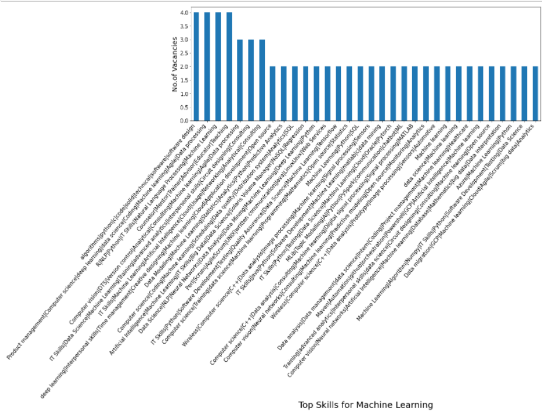

# **GitHub Link:** [**https://github.com/BageAman/Tasks.git**](https://github.com/BageAman/Tasks.git)

# **Conclusion:**

Employees and employers will be able to identify the needed experience and forthcoming skillset in the Data Science/ML job market, making it easier for any IT company to find a suitable applicant. Since 2016, Bengaluru has emerged as the world's fastest-growing mature IT sector, accounting for 50 percent of jobs in the entire state of India. Accenture Tech Company fills 25% of the tech employment. The dataset shows that there are more jobs for machine learning engineers. We need some talents to find a career in machine learning. Python, machine learning, data processing.

